**DAILY ONLINE ACTIVITIES SUMMARY**

|  |  |  |  |  |  |  |  |  |
| --- | --- | --- | --- | --- | --- | --- | --- | --- |
| **Date:** | **30/06/2020** | | | | | **Name:** | **Rohan Mahaveer** | |
| **Sem & Sec** | **6th /B** | | | | | **USN:** | **4AL17CS077** | |
| **Online Test Summary** | | | | | | | | |
| **Subject** | | **-** | | | | | | |
| **Max. Marks** | | **-** | | **Score** | | | **-** | |
| **Pre-Placement Training Summary** | | | | | | | | |
| **Pre placement training** | **Java** | | | | | | | |
| **Faculty** | | | Mr.Sharan Pais | | **Duration** | | | **2 hr** |
| **Coding Challenges** | | | | | | | | |
| **Problem Statement:**   1. Java program to create a doubly linked list of n nodes and display it in reverse order. | | | | | | | | |
| **Status: Completed** | | | | | | | | |
| **Uploaded the report in GitHub** | | | | | **Yes** | | | |
| **If yes Repository name** | | | | | <https://github.com/rohanmahaveer/daily-status> | | | |
| **Uploaded the report in slack** | | | | | **Yes** | | | |

**Training snapshots:**

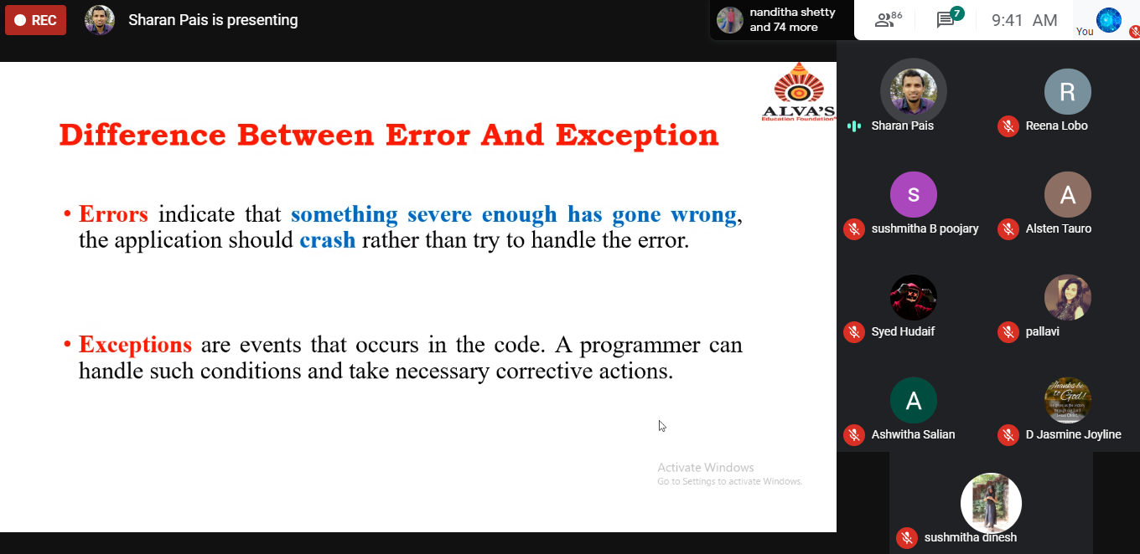

**Coding challenges :**

1 . Java program to create a doubly linked list of n nodes and display it in reverse order

